https://matlab.mathworks.com/

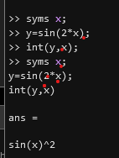 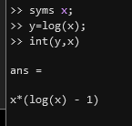 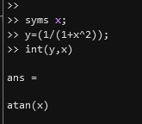

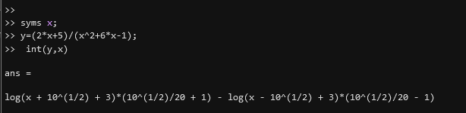

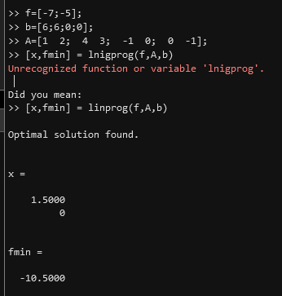

f=@(x)sin(2\*x);

y=sin(2\*x);

Unrecognized function or variable 'x'.

syms x;

y=sin(2\*x);

int(y,x);

syms x;

y=sin(2\*x);

int(y,x)

ans =  
   
sin(x)^2

syms x;

y=log(x);

int(y,x)

ans =  
   
x\*(log(x) - 1)

syms x;

y=(1/(1+x^2));

int(y,x)

ans =  
   
atan(x)

syms x;

y=(2\*x+5)/(x^2+6\*x-1);

 int(y,x)

ans =  
   
log(x + 10^(1/2) + 3)\*(10^(1/2)/20 + 1) - log(x - 10^(1/2) + 3)\*(10^(1/2)/20 - 1)

syms x;

y=(1/(1+x^2));

int(y,x)

ans =  
   
atan(x)

f=[-7;-5];

b=[6;6;0;0];

A=[1 2; 4 3; -1 0; 0 -1];

[x,fmin] = linprog(f,A,b)

Optimal solution found.  
  
  
x =  
  
 1.5000  
 0  
  
  
fmin =  
  
 -10.5000

f=@(x) x^2-37;

a=5;

b=7;

tol=0.001;

while abs(a-b)>=tol;

m=(a+b)/2;

if (f(a)\*f(m)<0)

b=m;

elseif(f(b) \* f(m)<0)

a=m;

end

end

root=m

root =  
  
 6.0830